**A**

**M I N I P R O J E C T R E P O R T**

**On**

**“****GYM-CONNECT a Gym Management system”**

Submitted by

**Sahu Deepak Kumar (SE-IT-38)**

**Urankar Neha (SE-IT-B-64)**

**Vaity Priyanshu (SE-IT-B-65)**

**Wanve Rachit (SE-IT-B-68)**

Under the guidance of

**“Prof.  J. R. Gaydhane ”**



Department of Information Technology

Datta Meghe College of Engineering,

Sector-3, Airoli, Navi Mumbai – 400 708, (M.S.), INDIA

**2024-25**

**Datta Meghe College of Engineering**

**(AICTE & Govt. of Maharashtra Recognized, Affiliated to University of Mumbai)**

**Department of Information Technology**



**C E R T I F I C A T E**

This is to certify that **Sahu Deepak Kumar, Div-B, Roll No.-38 / Urankar Neha Rajesh, Div-B, Roll No.-64/ Vaity Priyanshu Devendra, Div-B, Roll No.65 / Wanve Rachit Raju, Div-B, Roll No.-68** of Information Technology has executed the Project work in the Subject Mini Project 2A Web based Business Model Project entitled “ **GYM-CONNECT a Gym Management system**” carried out by him/her under my guidance and supervision within the institute.

**Signature of the Guide Signature of Head of Department**

**Examined on:**

**Examiner 1 Examiner 2**

**TABLE OF CONTENT**

|  |  |
| --- | --- |
| 1.Abstract | 5 |
| 2.Introduction | 6 |
| 3.Literature Survey | 7 |
| 4.Problem Definition | 9 |
| 5.Objectives | 10 |
| 6.Proposed Solution | 12 |
| 7.Implementation | 14 |
| 8.Testing | 19 |
| 9.Result and Analysis | 21 |
| 10.Conclusion | 21 |
| 11.Future Scope | 22 |
| 12.References | 23 |

**LIST OF FIGURES**

|  |  |  |
| --- | --- | --- |
| 0 Level DFD of Gym Management | 12 | |
| !st Level DFD Gym Admin Module | 12 | |
| 1st Level DFD Gym Member Module | 13 | |
| User Dashboard Page | 14 | |
| Payment Integration | 15 | |
| Stripe Checkout Page for Online Transaction | 16 | |
| Admin Subscription Page | 17 | |
| Admin Gym List Page | 18 |
| Subscription Data in Database (MongoDB) | 18 |

**ABSTRACT**

In the past, managing gym operations relied heavily on manual processes, creating inefficiencies and challenges for administrators and members alike. With the growing need for a more streamlined and automated approach, the development of a modern gym management system has become essential to simplify and optimize gym-related tasks. The aim is to improve the overall management of gym memberships, monthly subscriptions, payment processing, and user interactions, creating a seamless experience for both gym administrators and members.

By adopting advanced technology, this system seeks to reduce administrative burdens, enhance the efficiency of daily operations, and provide a user-friendly platform for members to access services. The solution is designed to foster better communication, more organized data handling, and improved member engagement, all while allowing administrators to efficiently oversee the gym's activities. Ultimately, the system aims to create a well-structured, easy-to-manage gym environment that elevates the experience for members and administrators, contributing to the gym's growth and overall satisfaction.

The gym management system will also incorporate advanced features such as personalized workout plans, and progress tracking, providing members with a holistic fitness experience. For administrators, the system offers a centralized dashboard to monitor key metrics, manage equipment, and process payments efficiently. By automating routine tasks and improving communication channels, the system not only enhances operational efficiency but also fosters member retention and satisfaction. This innovative solution will help gyms reduce complexity, minimize human error, and create a more engaging and productive environment for both staff and members

**Introduction**

In many gyms around the world, managing daily operations through outdated, manual methods has posed a significant challenge. Handling memberships, payments, and workout schedules using paper-based records or spreadsheets is not only cumbersome but prone to errors. However, as technology continues to evolve, adopting smarter, more efficient solutions is becoming essential. By leveraging modern tools, gym management can be transformed—streamlining everything from member registration to equipment tracking, workout planning, and complaint resolution.

Our goal is to develop a gym management system that ensures a smooth and hassle-free experience for all stakeholders. This system will simplify the workload for administrators while enhancing the overall gym experience for members. From the moment a new member signs up to tracking their fitness progress and managing payments, every aspect of gym operations will be optimized for efficiency and convenience.

Ultimately, our objective is to create a system that benefits both gym staff and members alike. It’s about building a platform where managing gym operations is straightforward and rewarding, catering to the needs of fitness enthusiasts and administrators. With this approach, we aim to revolutionize gym management, making fitness journeys more engaging and enjoyable for all involved.

**Literature Survey**

|  |  |  |  |
| --- | --- | --- | --- |
| **Title** | **Publication** | **Finding** | **Limitations** |
| Web based Gym Management System [1] | K.G.S.T, Gamage  University of Colombo School of Computing(e-ISSN: 2582-5208 ,05/May/2021) | Allows user to find gyms located in a local area. | The system may struggle to handle a large volume of users efficiently. |
| Gym Management System | St. Xavier’s College,  Jaipur(e-ISSN: 2456 – 6470, March-April 2022) | Overall functionality of the system shows that it work satisfactory and the result obtained shows that the system is error free. | Regular updates and maintenance may require significant resources, impacting cost-effectiveness |

**Analyzing the Existing System**

1. The system enables users to easily discover gyms located within their local area by providing a centralized platform for gym listings. It simplifies the search process, allowing users to filter gyms based on location, services, and membership options. This helps users quickly find gyms that meet their preferences without the hassle of manual searches or scattered information sources.
2. The overall functionality of the system demonstrates that it operates smoothly and efficiently, meeting the intended objectives. The results obtained during testing indicate that the system performs reliably without errors, ensuring a seamless user experience. This reflects the system's robustness and readiness for real-world application.

**Disadvantage of Existing System**

1. The system may struggle to handle a large volume of users efficiently
2. Regular updates and maintenance may require significant resources, impacting cost-effectiveness

**Problem Definition**

The problem definition centers around the need to streamline the process of finding and subscribing to gyms within a locality. Currently, individuals seeking a gym face significant challenges due to the fragmented nature of information and services. Traditional methods of gym discovery and subscription often lack efficiency, transparency, and convenience.

**Objectives**

* With the system, managing gym member data becomes quick and efficient. Gym owners can easily access and update member details, such as personal information and membership plans, through a digital platform. This reduces manual work and ensures accurate information is always readily available.
* The system simplifies tracking memberships by providing details like start dates, renewal status, and payment history. Gym owners can easily monitor memberships and receive automated reminders, reducing administrative tasks and ensuring smooth membership management.
* Users will have access to comprehensive information about local gyms, including membership plans and facilities. The system allows users to compare gyms, view reviews, and subscribe to their preferred gym, making gym discovery and decision-making easier.
* The system includes a secure payment interface, allowing users to pay for memberships, renewals, or upgrades easily. Multiple payment options will be available, streamlining the payment process for both members and gym owners.
* Gym owners can monitor memberships in real-time, viewing active, expiring, or expired plans. This helps them take timely action, maintain member engagement, and ensure efficient operations.

**Scope**

The scope of this project encompasses the development of a user-friendly web application aimed at providing gym owners and members with convenient access to essential information and services. By leveraging technologies such as React, Node.js, Express.js, and MongoDB, the system will streamline various operations, including member management, payment processing, and timely notifications, thereby significantly reducing manual effort. Comprehensive data management features will be integrated to effectively track memberships, workout plans, and gym details, enhancing both member satisfaction and operational efficiency. Designed with scalability in mind, the Gym Management Website will outline a broad range of functionalities and services, ensuring that it can adapt to the evolving needs of gym owners and members. Ultimately, this project seeks to make gym operations smoother and more enjoyable for everyone involved, creating a more engaging fitness environment.

**Proposed Solution**

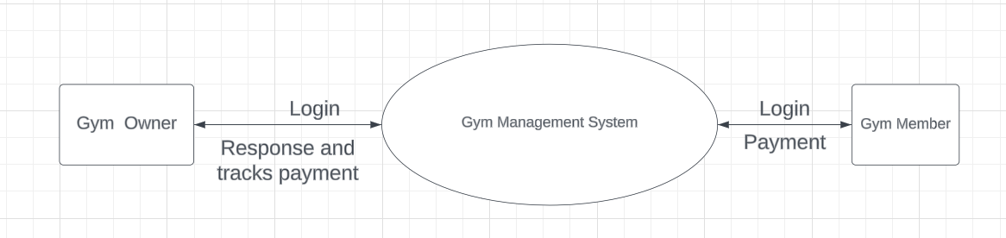

# 0 Level DFD of Gym Management

# This diagram represents a Gym Management System. It shows two main user roles: Gym Owner and Gym Member. Both users interact with the system through a login process. The Gym Owner has access to the core system for managing gym operations, including tracking payments and responses. Gym Members log in to access features related to their membership, including booking classes, viewing workout plans, and potentially making payments. The system acts as a central hub for communication and data management between the gym owner and members.

# 

# 1st Level Gym Admin Module

# This diagram outlines the functionalities of a gym management system. An admin can log in to add new gyms, update existing gym information, and view a list of all gyms. Additionally, the admin can manage subscriptions and track payment statuses, including pending and completed payments. The system maintains an admin database to store and manage this information.

# 

# Gym Member Module

# This diagram illustrates the user flow for a gym membership system. A user starts by logging in and accessing their dashboard. They then choose a desired gym membership and confirm their subscription. Before completing the purchase, they provide customer information and proceed to payment integration. The system offers both online and offline payment modes. Once payment is successful, the user's information is updated in the user database, completing the membership process.

**Implementation**

The Gym Management Website is developed within the VS Code environment, a powerful code editor known for its flexibility and extensive support for various programming languages, which enhances productivity and streamlines the development process. Leveraging a modern tech stack that includes HTML, CSS, and JavaScript for the frontend, along with React for building dynamic user interfaces, the project ensures an engaging user experience. On the backend, Node.js and Express facilitate efficient server-side operations, enabling seamless communication between the client and server. MongoDB serves as the database management system, allowing for efficient data handling and retrieval, which is crucial for managing member information, workout plans, and payments. This comprehensive setup fosters a streamlined development process, ensuring the application is both reliable and scalable.

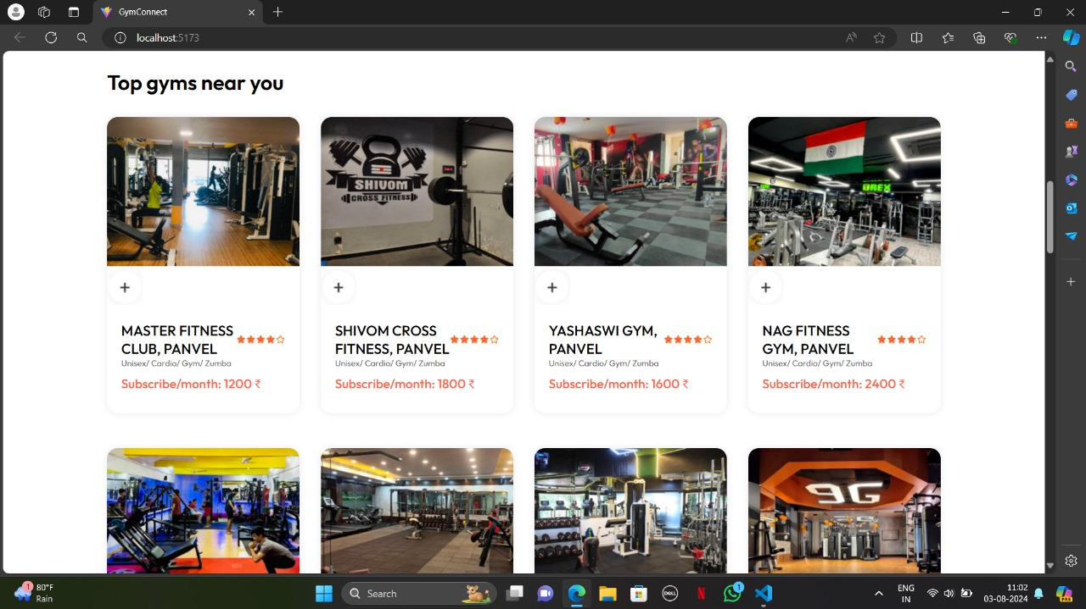

**GymConnect: User Dashboard Page**

This webpage, GymConnect, is a convenient platform designed to help individuals discover top-rated gyms in their local area. It provides a user-friendly interface to search for gyms based on various criteria, such as location, amenities, and subscription fees. By showcasing detailed information about each gym, including its name, address, facilities, and membership plans, GymConnect empowers users to make informed decisions and find the ideal fitness center that suits their needs and preferences

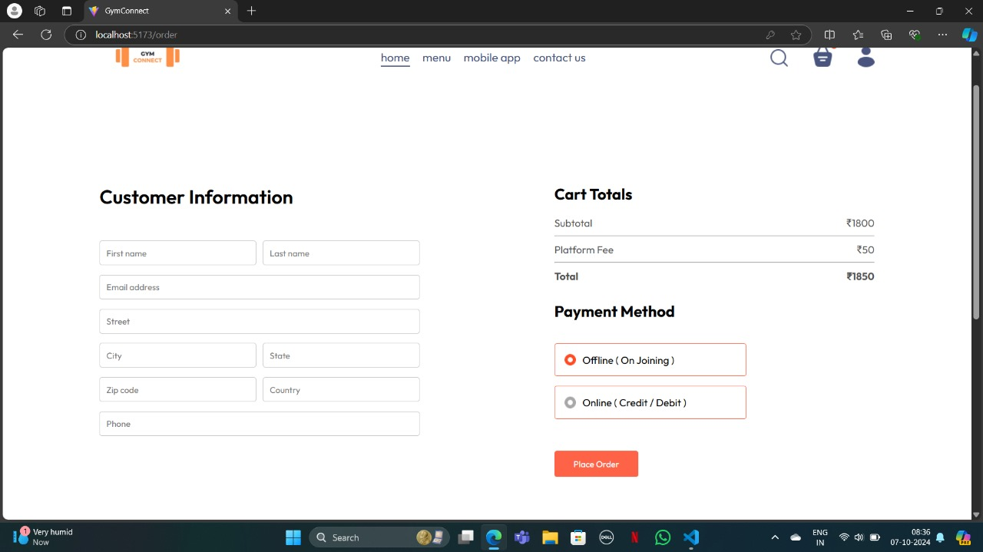

**Payment Integration**

This webpage is likely a checkout page for a gym membership on a website called GymConnect. It prompts the user to enter their personal information, including name, address, and contact details. The page also displays the order summary, including the subtotal, platform fee, and total amount. Users can choose between offline payment (on joining) or online payment using credit or debit cards. Finally, there is a "Place Order" button to complete the purchase.

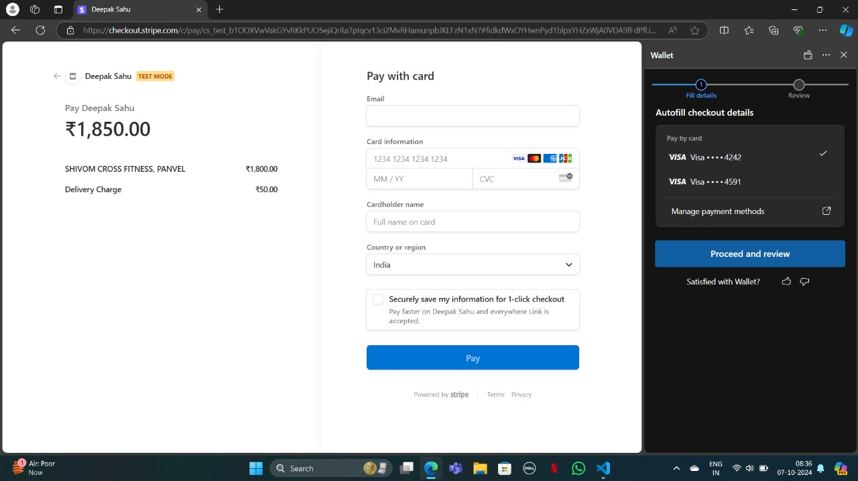

**Stripe Checkout Page for Online Transactions**

This webpage appears to be a checkout page for a gym membership purchase. It displays the order summary, including the gym name, membership fee, and delivery charge. The user is prompted to enter their card details, including number, expiration date, CVC code, and cardholder name. There is also an option to securely save card information for faster future purchases. After entering the required information, the user can proceed to review the order and complete the payment.

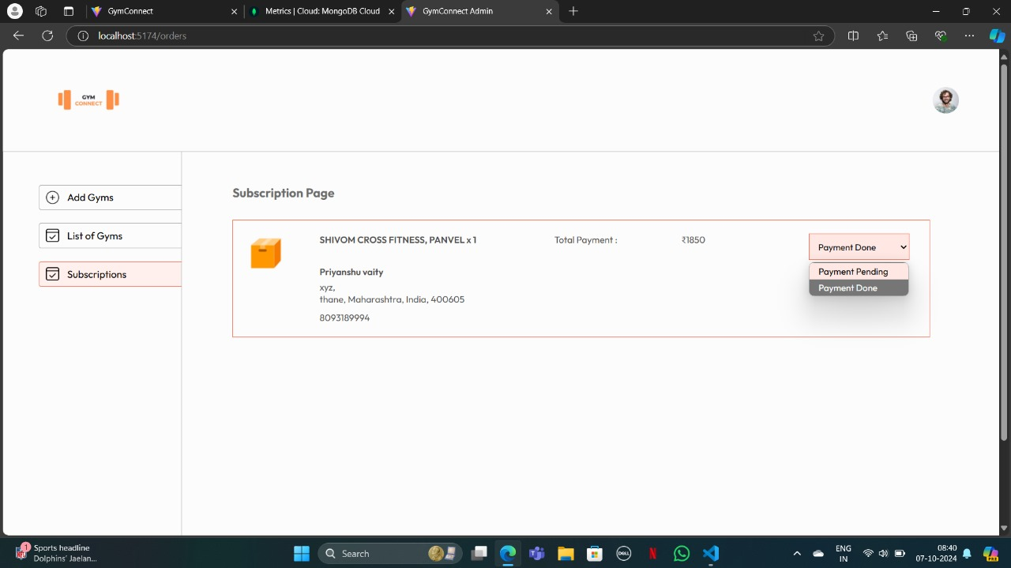

**Admin Subscription Track Page**

This webpage appears to be an admin dashboard for managing gym subscriptions on a platform called GymConnect. It shows a list of subscriptions, including the gym name, member details, total payment amount, and payment status. The admin can likely view and manage these subscriptions, potentially updating payment information or canceling memberships. There is also a section for adding new gyms and viewing a list of all gyms on the platform

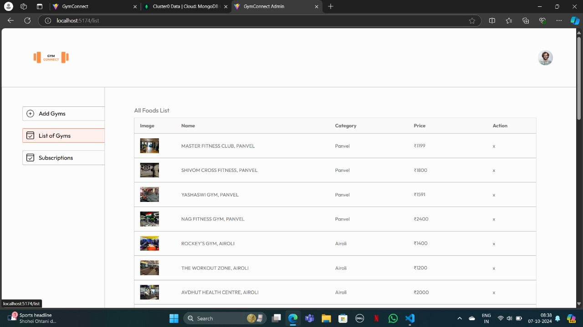

**Admin Gym List Page**

This webpage appears to be an admin dashboard for managing a list of gyms. It allows the admin to view the name, location, and price of each gym. There are also options to add new gyms and potentially edit or delete existing ones. The overall purpose of this page is to provide an overview of the gyms available on the platform and facilitate their management.

# 

**TESTING**

Testing an application to its smallest unit is called Unit Testing. Again, testing each module of an application which numerous test cases and checking validations against unforeseen scenarios is what unit testing is all about. Once a bug is detected, that is recorded in the bug tracker, a ticket is raised, this bug is fixed, and again new unit test cases are written to perform unit testing over the debugged piece of code.

|  |  |  |  |  |  |  |  |  |  |  |  |  |  |  |  |  |  |  |  |  |  |  |  |  |  |  |  |  |  |  |  |  |  |  |  |  |  |  |  |  |  |  |  |  |  |  |  |  |  |  |  |  |  |  |  |  |  |  |  |  |  |  |  |  |  |  |  |  |  |  |  |  |
| --- | --- | --- | --- | --- | --- | --- | --- | --- | --- | --- | --- | --- | --- | --- | --- | --- | --- | --- | --- | --- | --- | --- | --- | --- | --- | --- | --- | --- | --- | --- | --- | --- | --- | --- | --- | --- | --- | --- | --- | --- | --- | --- | --- | --- | --- | --- | --- | --- | --- | --- | --- | --- | --- | --- | --- | --- | --- | --- | --- | --- | --- | --- | --- | --- | --- | --- | --- | --- | --- | --- | --- | --- |
| |  |  |  |  | | --- | --- | --- | --- | | **Module** | **Test Case** | **Executed Result** | **Observed Result** | | Admin/Member | User tries to Login | User does not exist | Fail | | Admin/ Member | Provides invalid username | User not found | Fail | | Admin/ Member | Provides wrong password | Username password does not exist | Fail | | Admin/ Member | Click on Login | Homepage Opens | Pass | | Admin | Add new gym | Gym added Successfully | Pass | | Admin | Check member subscription in gym | Gym is empty | Fail | | Member | Choose gym subscription | Gym subscription process procceds | Pass | | Member | Enter Phone Number  (10 digits int) | Added Successfully | Pass | | Member | Enter Gmail | Please include @ symbol | Fail | | Member | Enter wrong format Phone Number | Please enter 10 digit numbers | Fail | | Member | Enters wrong address format | Please enter correct address format | Fail | | Member | Enters correct address format | Procced to payment | Pass | | Member | Subscription Payment by correct entering card details ,CVC no. ,Expiry Date and Cardholder name | Online payment through Stripe | Pass | | Admin/Member | Subcription added | Visible on both intefaces | Pass | | Admin | Checks the subscriptions | Current Members Successfully visible | Pass | | Admin | Checks the gyms | Current Gyms Successfully visible | Pass | | Admin | Remove Gym/Member after certain period | Changes saved successfully | Pass | |

**Tests performed on module**

**Result and Analysis**

Our gym management system has led to significant enhancements in operational efficiency and member satisfaction. By streamlining data management and automating membership tracking, we have alleviated administrative burdens for gym owners, allowing them to focus on improving member experiences. Integrated payment processing and progress tracking have simplified financial transactions and fitness management, contributing to quicker response times and improved communication with members. User feedback indicates that the system has made it easier for members to access information and services, fostering a more engaging gym environment.

Moving forward, continuous improvement and adaptation will be essential to maintain these benefits and further optimize gym operations. Our ultimate goal is to create a gym management system that meets the needs of both gym owners and members, ensuring a seamless and rewarding fitness experience for all stakeholders involved.

**Conclusion**

In summary, the transition from manual gym management to a technology-driven system marks a significant improvement in efficiency. By eliminating tedious record-keeping and simplifying daily operations, the Gym Management Website aims to make life easier for both gym owners and members. Our focus extends beyond just easing administrative tasks—we are creating a platform that ensures a seamless, enjoyable experience for everyone involved. This project will offer numerous benefits, including enhanced efficiency, better communication, and smoother management of memberships, payments, and gym activities. With this approach, we are ushering in an era where managing a gym becomes not just efficient but truly rewarding.

**Future Scope**

The future scope of the gym management system project includes several practical enhancements aimed at improving user experience and operational efficiency. One potential development is the creation of a mobile application that allows gym members to access their workout plans, membership details, and payment options conveniently from their smartphones. Additionally, integrating advanced analytics could provide gym owners with valuable insights into member behavior and attendance patterns, helping them make informed decisions.

Incorporating communication features such as in-app messaging and notifications could foster better interaction between members and gym staff, creating a sense of community. Furthermore, offering customizable membership plans would allow members to tailor their subscriptions to meet their individual needs, while the introduction of virtual training sessions could accommodate those who prefer to work out from home. These enhancements are achievable and would significantly enhance the overall functionality of the gym management system, making it more responsive to the needs of both gym owners and members

**Limitations**

While the gym management system offers many benefits, it has some limitations. One major drawback is its reliance on internet connectivity, which can hinder access in areas with poor network coverage. Additionally, the system requires regular updates and maintenance, which may lead to occasional downtime. Some users, particularly those less comfortable with technology, might struggle to navigate the platform. Initial development and ongoing costs could also pose challenges for smaller gyms. Finally, ensuring data security and privacy is crucial to protect sensitive member information and maintain trust.

**References**

1. Zhao, Dong, Fei Wang, and Xiao-feng Zhu. "Design and Implementation of Gym Management System Based on Web." In *2023 2nd International Conference on Educational Innovation and Multimedia Technology (EIMT 2023)*, pp. 44-51. Atlantis Press, 2023.
2. Gamage, K. G. S. T. "Web based Gym Management System." PhD diss., 2017.
3. Thapa, Mahesh. "Gym Management System." *EDITORIAL BOARD*: 9.
4. Srivastava, Aman, and Suresh Annamalai. "AI Based Gym Management System with Body Performance Index measurement and Tips." In *2024 2nd International Conference on Networking and Communications (ICNWC)*, pp. 1-7. IEEE, 2024.